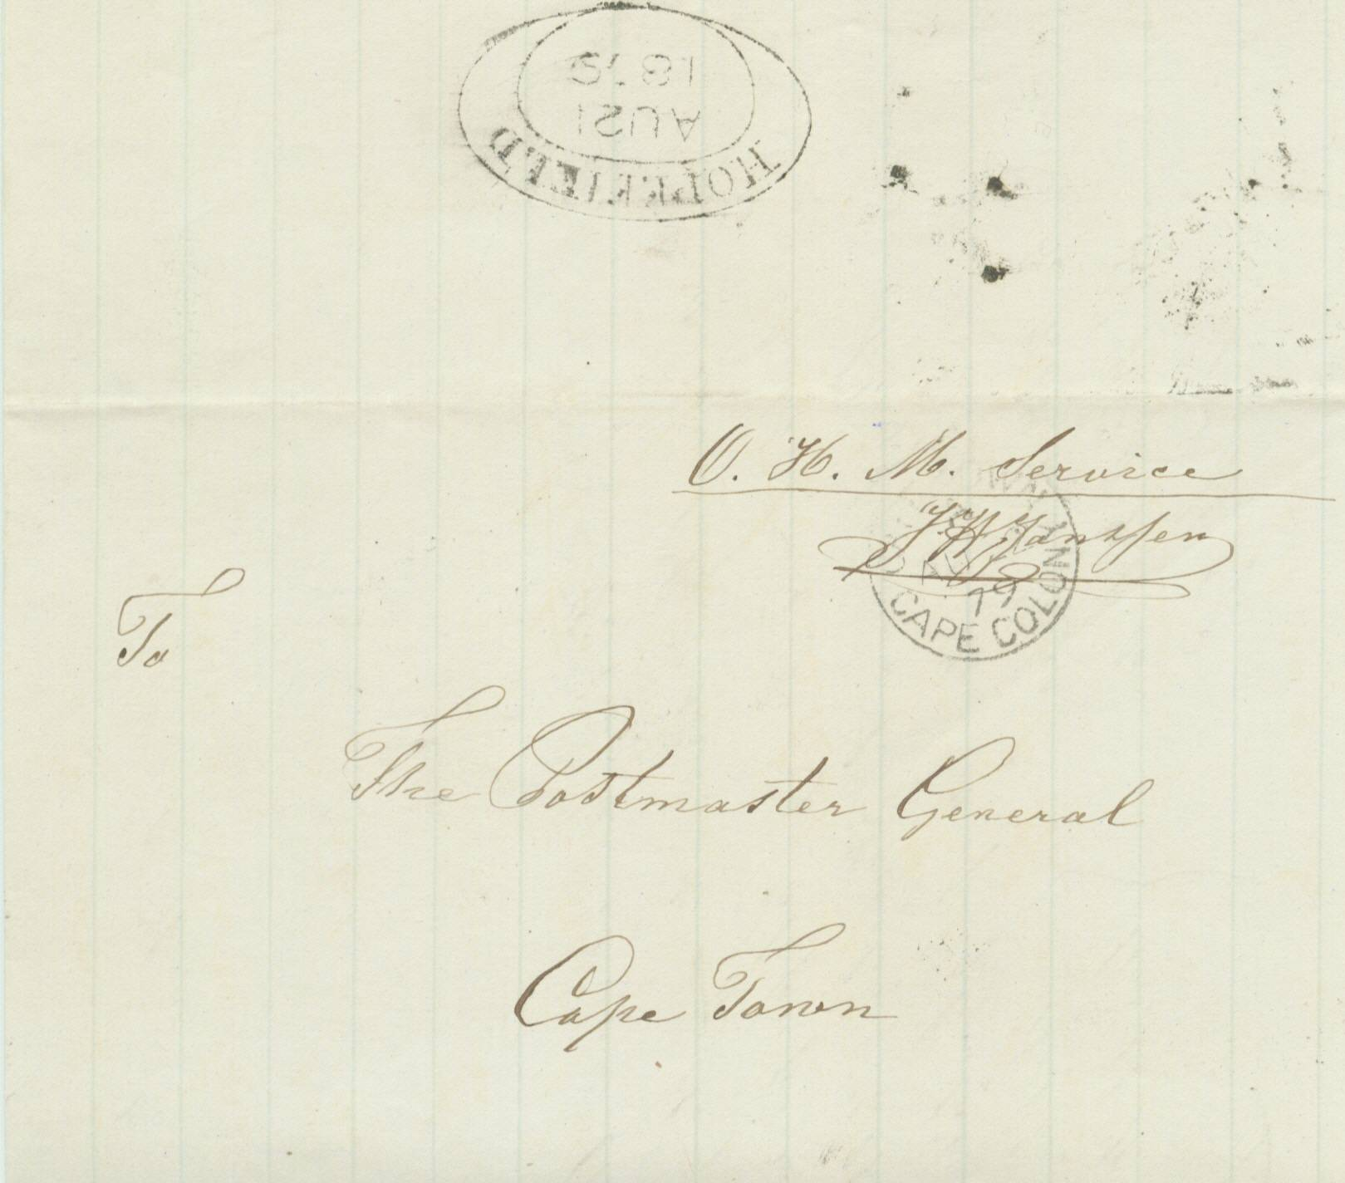
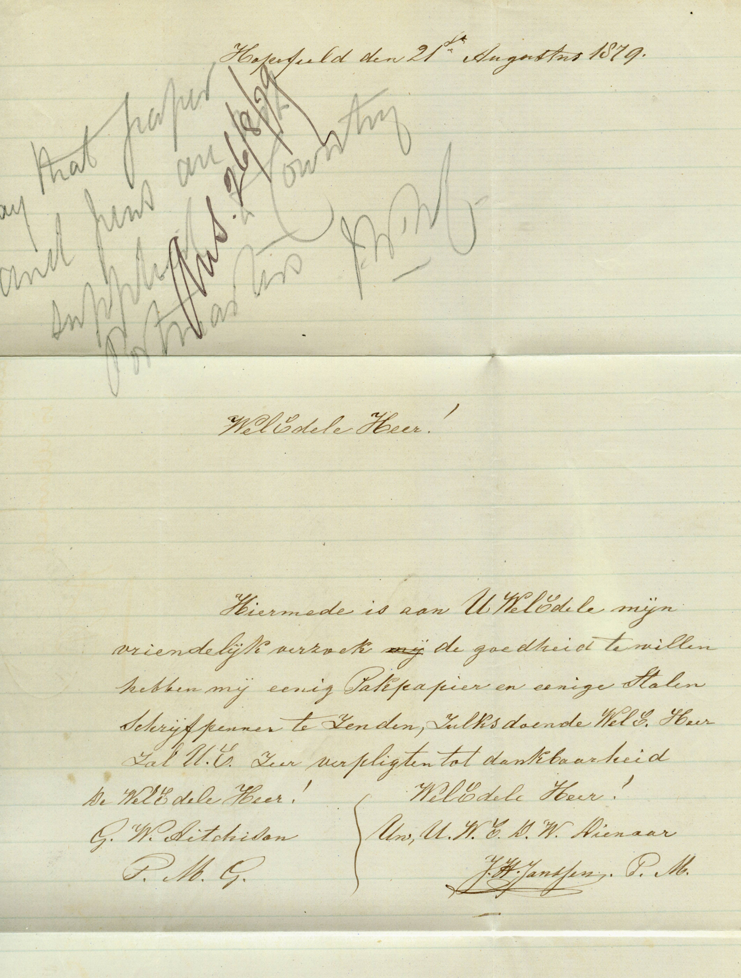
+

HOPEFIELD

Signed letter from Postmaster J.H.Janssen at Hopefield to Postmaster General Cape Town, requisitioning writing paper and steel pens. Note by J.W.Morgenrood (secretary) about the letter inside, to his clerk, reads “say that paper and pens are not supplied to country Postmasters.
J W.M.” Top backflap has been opened out showing a fine black strike of the “HOPEFIELD” Dated Town Oval of “21 August 1879”.
An extremely rare letter from Janssen.
Reduced facsimile of other side of lettersheet.

CAPE OF GOOD HOPE

DEVELOPENT OF POSTAL SERVICES

The Dated Town Oval

Handstamps of 1853

